Computer Games Collection

User guide

30003389 – Kyer Potts

Table of Contents

Getting started 2

Interface Elements 3

Collection List Window 3

Entry Input Fields 3

Add Button 3

Delete Button 4

Clear Button 4

Reset Button 4

Update Button 5

Save Button 5

Open Button 5

# Getting started

When ComputerGamesCollection first loads, the user will be notified that there no save file currently exists. A save file will automatically be created when the program is closed, and the user will not receive this message again unless the file is deleted from the directory.

To begin adding entries into the program, populate the Name, Platform and Genre fields and click the add button. The data will then be collated and sorted into the list on the right-hand side of the UI.

Once an entry has been made, the user will be able to edit, delete, or search for entries within the collection.

# Interface Elements

### Collection List Window

The collection list window displays your games collection in a selectable list. This list is automatically sorted for readability

### Entry Input Fields

Entry input fields will take user input for a variety of functions and will also display the relevant information when an entry is selected from the collection list window.

### Add Button

The add button will add data within the Entry Input Fields to Collection List Window. All Entry Input Fields must contain data for this button to function

### Delete Button

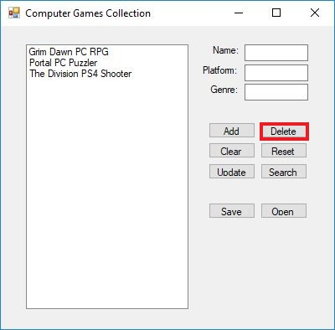

The Delete button will remove the entry selected in the Collection List Window from the program. An entry must be selected for this button to work

### Clear Button

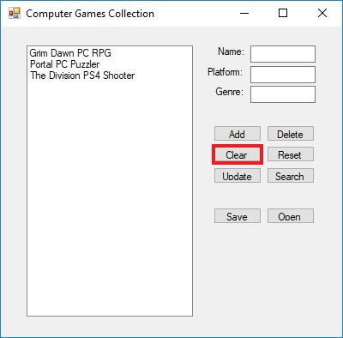

The clear button will empty the Entry Input fields of all data

### Reset Button

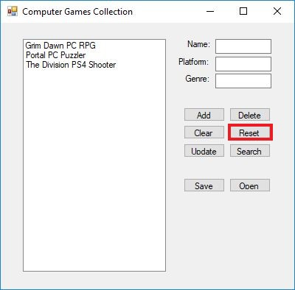

The Reset Button will wipe all data in the collection and begin a new list

### Update Button

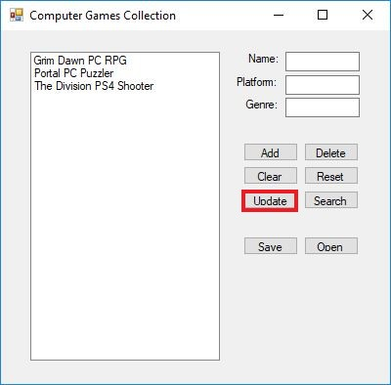

The update button will modify the data of the selected entry within the Collection List Window with new data from the Entry Input Fields

### Save Button

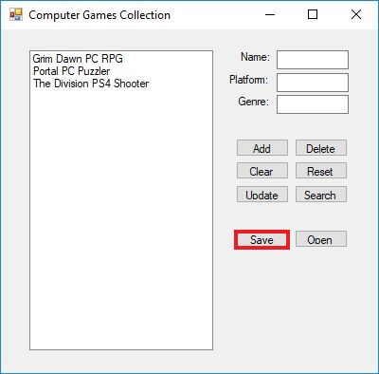

The save button will save all data within your collection. The program will also automatically save all data when the program is terminated

### Open Button

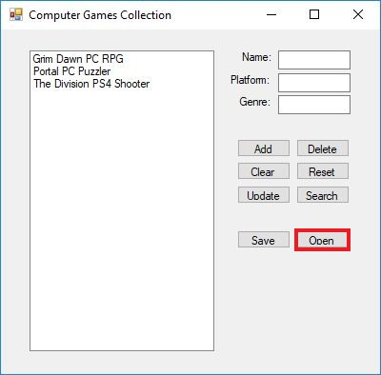

The Open button will load all previously saved data into the collection. This function will also automatically occur when the program begins.